| **Job Sheet** |
| --- |

| **Module** | **:** | IoT Fundamentals | **Module Code** | **:** | EC33105FP | |
| --- | --- | --- | --- | --- | --- | --- |
|  |  |  |  |  |  | |
| **Job No** | **:** | 3 | **Duration** | **:** | F/T: | 5 hours |
|  |  |  |  |  | P/T: |  |

| **Job Title** | **:** | Terminal and Python Basics |
| --- | --- | --- |
|  |  |  |
| **Objectives** | **:** | 1. Prepare RPi and Upswift 2. Terminal Basics 3. Python Basics |

**Tools, Equipment and Materials**

| PC |
| --- |
| RPi with microSD |
| RPi Power Adaptor  Breadboard  4G WiFi Router |
|  |

**Number of Tasks to Complete**: 10

The terminal app and python will be used extensively in the next few job sheets. As such, it is good to have some fundamentals on how to perform certain operations. Necessary terminal commands and python syntax is covered in the tasks below.

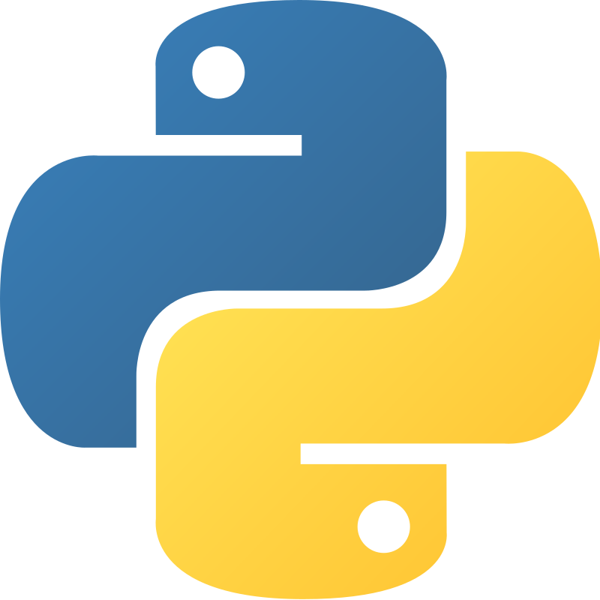

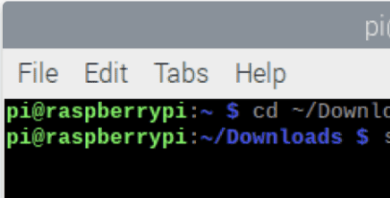

**Part A: Prepare RPi and Upswift (0.5 hour)**

Before performing any hardware configurations, we need to ensure that the RPi is accessible remotely.

YOU MUST HAVE COMPLETED JOB 1 BEFORE DOING THIS

**Task 1 – Prepare RPi and UpSwift**

Perform the following steps to setup RPi:

1. Connect only the power adaptor to RPi.
2. Turn on the power
3. Go to <https://dashboard.upswift.io/dashboard/> and login. The device would be **offline**.

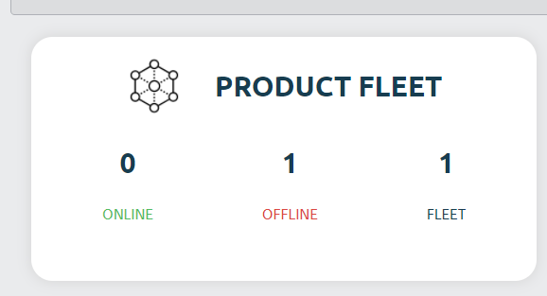

1. Wait for a while and refresh the web page by clicking . Device should appear online after 1 - 2 mins.

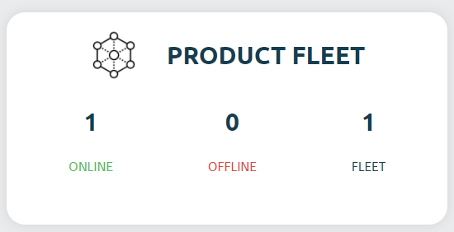

1. On the left side of your menu, click on the **Control** option under Control center.

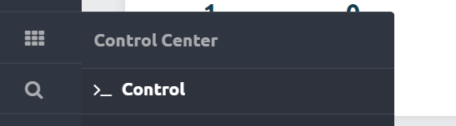

1. On the page center, select your device and click open session.

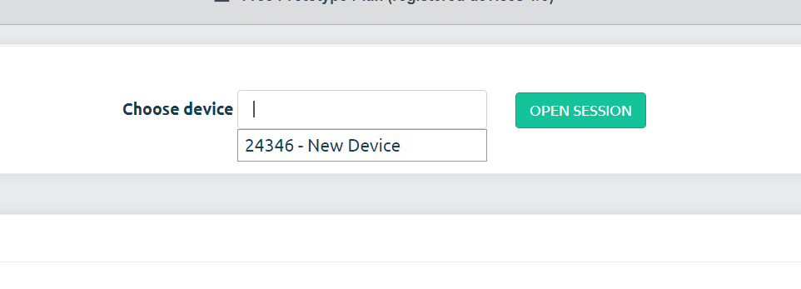

1. For the prompt, click **Open Remote Control.**

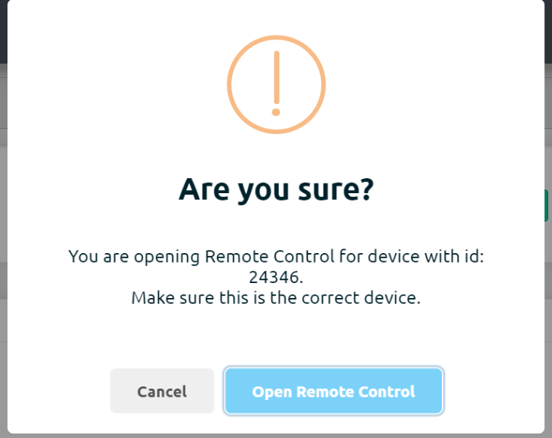

1. You will be shown a secret key. Click on **Copy to clipboard** button

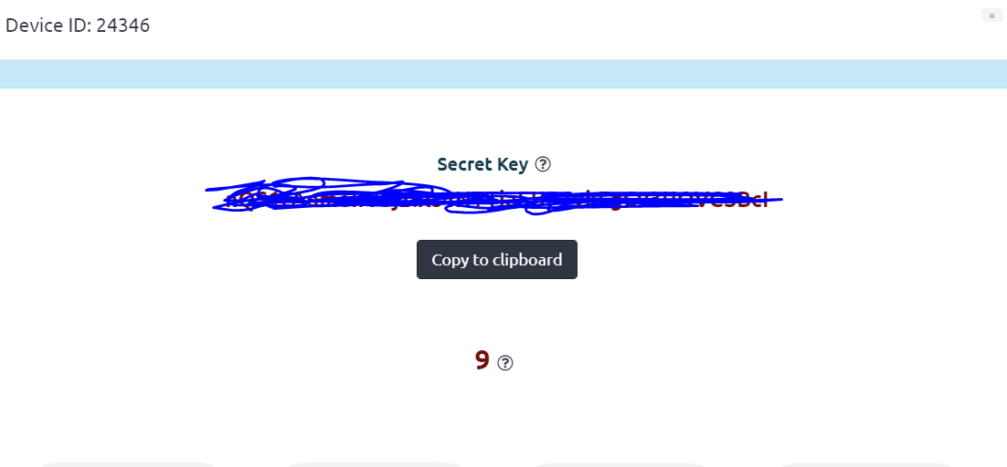

1. Once the timer is up, click on the **Open Remote Control** button.

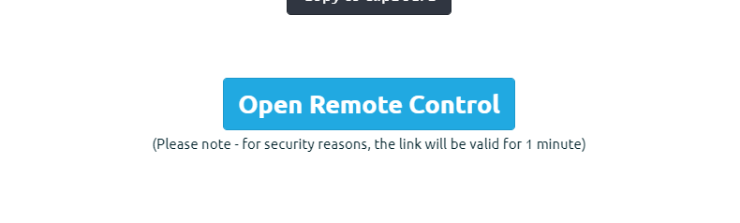

1. **Paste** the secret key in the input text box and change username to pi. Click on **Connect**.

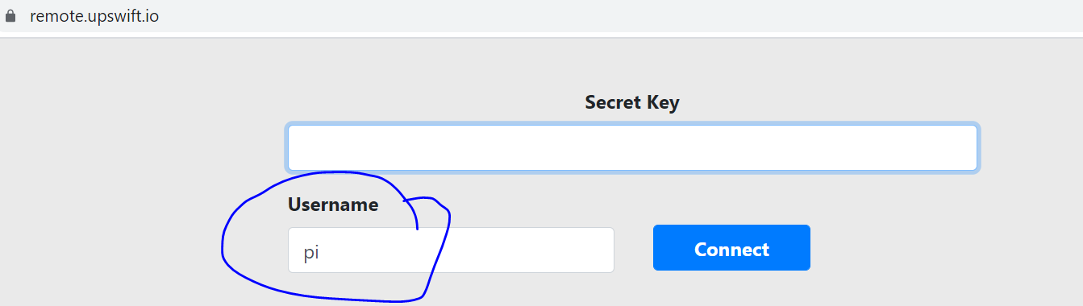

1. You will be presented with a browser based RPi terminal.

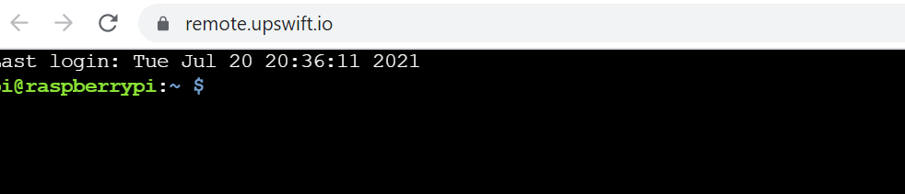

**Part B: Terminal Basics**

The default CLI that comes with the Raspberry Pi OS is the LXTerminal, also known as terminal emulator. We will learn some commands in the following tasks.

**Task 2 – Create a Folder (mkdir, pwd and ls)**

Perform the following steps

1. Watch the video to learn how to create a folder using commands.

<https://youtu.be/wVh5ZO8eXR4>

1. Create a new folder named **Job3.**
2. Check if the folder has been created successfully.

**Task 3 – Go into Folder and create file (cd, nano and ls with options)**

Perform the following steps

1. Watch the video to learn how to go into a folder and create a file.

<https://youtu.be/18VwPcuuxug>

1. Go into the **Job3** folder and create a file called **test.py.**
2. Check if the file has been created successfully.

**Task 4 – Delete file (cd, rm and ls)**

Perform the following steps

1. Watch the video to learn how to delete a file.

<https://youtu.be/T8kzOpm1q8A>

1. Delete the **test.py** script**.**
2. Check if the file has been deleted successfully.

**Task 5 – Delete folder (cd, rm and ls)**

Perform the following steps

1. Watch the video to learn how to delete a folder.

<https://youtu.be/Ig0kTgs-aHo>

1. Delete the **Job3 folder.**
2. Check if the folder has been deleted successfully.

**Part C: Python Basics**

**Task 6 – Create and Execute Python Script**

Perform the following steps

1. Watch the video to learn how to create and execute a python script.

<https://youtu.be/E02XbTSbTO0>

1. Create a new python script named **task2.py.**
2. Type the following code into the editor.

<https://github.com/Prakashash18/iot-fundamentals/blob/main/job3_6.py>

1. Save the script by pressing CTRL and X.
2. Execute the script.
3. Show your working script to your lecturer.

**Task 7 – Python Variables**

Perform the following steps

1. Watch the video to learn how to create variables in python.

<https://youtu.be/ae4GLZg8-jo>

1. Create a new python script named **task3.py.**
2. Type the following code into the editor.

<https://github.com/Prakashash18/iot-fundamentals/blob/main/job3_7.py>

1. Save the script by pressing CTRL and X.
2. Execute the script.
3. Show your working script to your lecturer.

**Task 8 – Python functions and Indentation**

1. Watch the video to learn how to use indentations in python.

<https://www.youtube.com/watch?v=R_aNLf1syps>

1. Create a new python script named **task4.py.**
2. Type the following code into the editor.

<https://github.com/Prakashash18/iot-fundamentals/blob/main/job3_8.py>

1. Fix any indentation issues present in the script.
2. Save the script by pressing CTRL and X.
3. Execute the script
4. Show your working script to your lecturer.

**Task 9 – Python If Else**

1. Watch the video to learn how to write if else statements in python.

<https://youtu.be/GJPmpXDkMns>

1. Create a new python script named **task5.py.**
2. Type the following code into the editor.

<https://github.com/Prakashash18/iot-fundamentals/blob/main/job3_9.py>

1. Edit the humidity condition to **be greater than 15.**
2. Save the script by pressing CTRL and X.
3. Show your working script to your lecturer.

**Task 10 – Python Imports**

1. Watch the video to learn how to import libraries and use them in python.

<https://youtu.be/K2N6SSX0QSo>